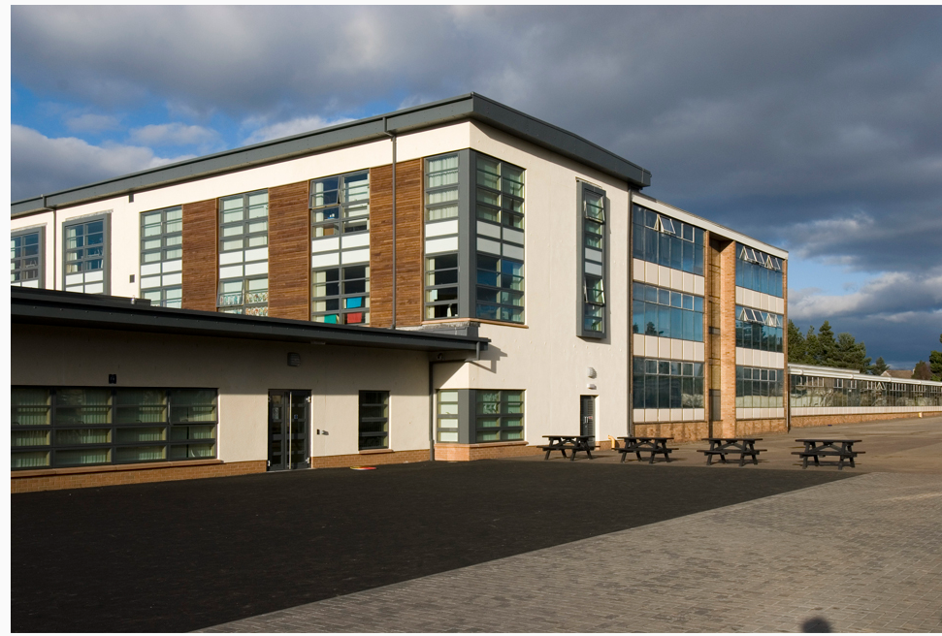
Information for Parents
Forthill Primary School
Click here

